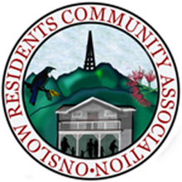
membership APPLICATION form 2026

onslow residents community association
We welcome any individual or organisation resident in the Broadmeadows, Khandallah and Kaiwharawhara areas to join the Onslow Residents’ Community Association (ORCA).
To apply, please complete this form, sign, scan and email it to onslowcommunityassn@gmail.com (or post it to address below).
Name
Org (if applicable)
Phone |  | Mobile
Email
Street Address
Suburb |  | Postcode

If you/your organisation are not resident in the Broadmeadows, Khandallah and Kaiwharawhara areas, please describe how you have an established current connection to the areas concerned:

…………………………………………………………………………………………………………………

…………………………………………………………………………………………………………………

Should this application be accepted, I/my organisation consent to becoming a member of ORCA.

Signed …………………………….………..……………… Date: ……………………………………..

We keep membership details private and only use them for Association business.

Annual membership subscription
Our current subscription rates can be found on our website at https://onslowcommunity.org.nz.
Our contact details
Email: onslowcommunityassn@gmail.com
Post: ORCA, c/o Khandallah Town Hall, 11 Ganges Road, Khandallah, Wellington 6035

Thank you!

