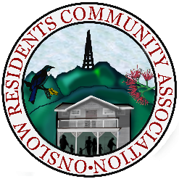
Committee Member Nomination Form 2026/2028
Nominations for Committee Member to be elected at ORCA’s AGM (for 2 year term) – Tuesday, 24 March 2026 at 7:30pm.
Please note: Nominees, proposers and seconders
must be current financial members of ORCA
Please complete & return this form (together with a “Consent and certificate of officer” form completed by the nominee) by 5pm, Tuesday, 17 March 2026 to ORCA Secretary, Paul Carey at onslowcommunityassn@gmail.com
Or for more information, please ring 027 422 5934

Nominee (name)
Nominee (signature)
Proposer (name)
Proposer (signature)
Seconder (name)
Seconder (signature)
Date

Nominee (name)
Nominee (signature)
Proposer (name)
Proposer (signature)
Seconder (name)
Seconder (signature)
Date

