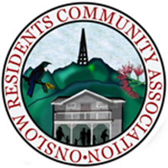
membership APPLICATION form 2025

onslow residents community association
We welcome any individual or organisation resident in the Broadmeadows, Khandallah and Kaiwharawhara areas to join the Onslow Residents’ Community Association (ORCA).
To apply, please complete this form and email it to onslowcommunityassn@gmail.com (or post it to address below). Deposit the membership subscription (see schedule below) to ASB Account: ONSLOW RESIDENTS' COMMUNITY ASSOCIATION INCORPORATED 12-3223-0204207-00 (please put your street address in Particulars and your last name in Reference).
Name *
Org (if applicable) *
Phone |  | Mobile
Email *
Street Address *
Suburb * |  | Postcode *
* Required information
We will keep your membership details private and only use them for Association business.

Annual membership subscription
Please use our current subscription rates in the following table:
Individual | $10 per year
Household | $10 per year for the first ordinary member, plus $5 per year for each additional member living at the same address
Organisation | $20 per year
Student | $5 per year

Our contact details
Email: onslowcommunityassn@gmail.com
Phone: 027 422 5934
Post: ORCA, c/o Khandallah Town Hall, 11 Ganges Road, Khandallah, Wellington 6035

Thank you!

