Welcome to the fifth newsletter of the Onslow Residents’ Community Association (ORCA) working to improve the neighbourhoods of Khandallah, Broadmeadows and Kaiwharawhara.
To join ORCA, or for more information, contact us at onslowcommunityassn@gmail.com
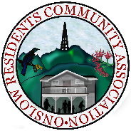

ORCA News and Views

Issue 5 – September 2019
Message from the President
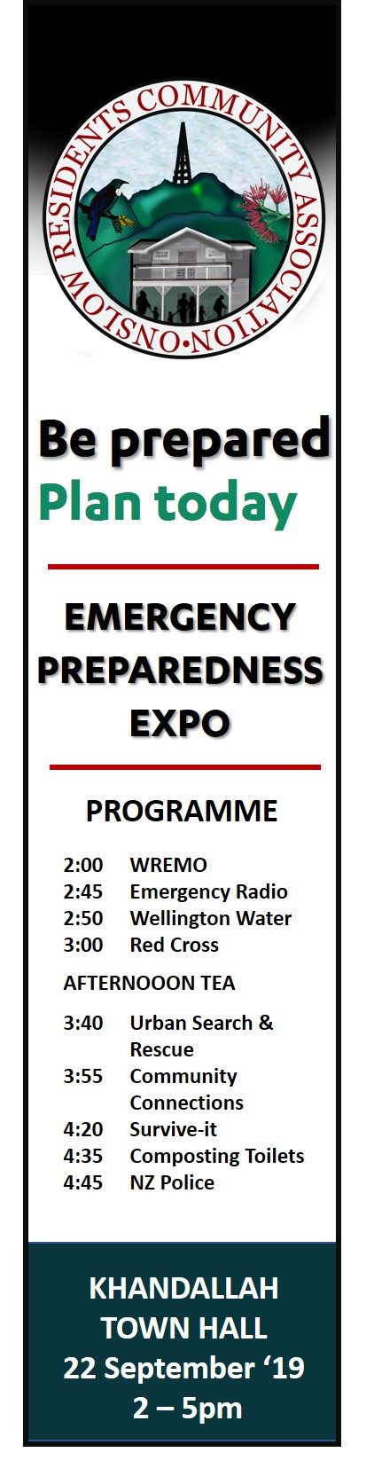
Kia ora katou
It is an exciting time for ORCA with a number of Community events planned in the next two months. This includes the Emergency Preparedness Expo on Sunday, 22 September and the Living Sustainably Expo on Tuesday, 29 October 2019. We encourage all community members to come along to the Khandallah Town Hall and hear from the experts in these two areas and see some exciting displays.
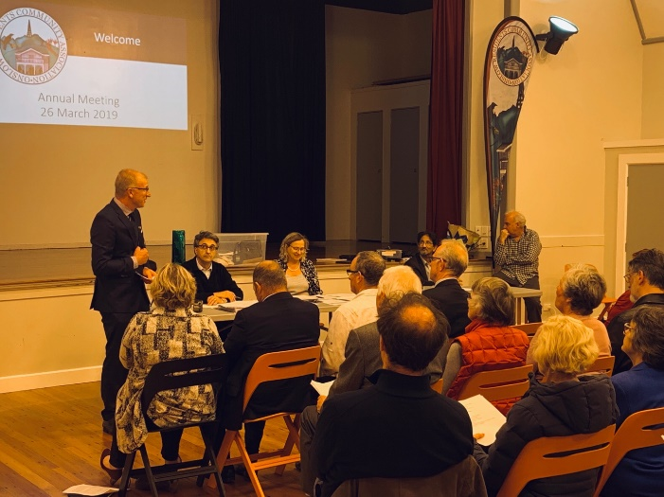
It was great to see so many of our members at our Annual Meeting last April. At this meeting we heard from Greater Wellington Regional Council Chief, Greg Campbell. He talked about the wide ranging work of the Regional Council. We recognise the challenges the Council is facing. One is the bedding in of the new bus system. For our area, the new bus system has some wins, such as the more frequent service for Broadmeadows. However, the service through Khandallah is less than satisfactory with morning bus service issues especially continuing to inconvenience passengers. The GWRC is inviting community consultation on their bus review and we hope that community members were able to attend the public drop-in workshops on 14 September at Khandallah Presbyterian Church. You can also have your say at https://haveyoursay.gw.govt.nz/busreview
Ngā mihi nui
Nicola McFaull, President, Onslow Residents’ Community Association

Cornerstone Community Trust AGM
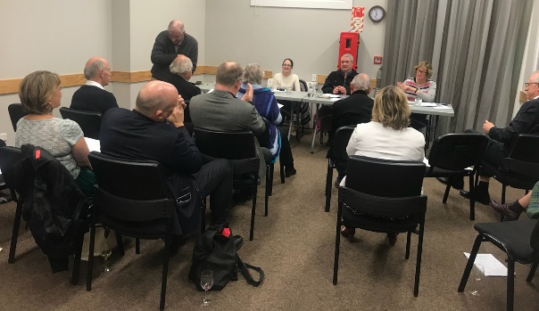
ORCA attended the Cornerstone Community Trust AGM last July 2019. Cornerstone runs the Khandallah Town Hall on behalf of the Wellington City Council. Members of the Trust were instrumental in renovating the town hall and the wonderful Fiona and Sarah capably manage the operations which see over 25,000 people go through the hall each year. This includes many of our members. We are grateful that the Town Hall also provides a place for ORCA to meet each month.
What will you do when the Big One Strikes?
As part of our long term strategy to improve the resilience of our community and encourage every house on every street to be prepared for an emergency, ORCA is holding an Emergency Preparedness Expo on Sunday, 22 September 2019 from 2-5pm at the Khandallah Town Hall. We invite all our members to attend this important event that could save your life and your families’ lives.
To ensure your seat and to go into the draw to win an emergency preparedness kit, you can register at https://www.eventbrite.co.nz/e/orca-emergency-preparedness-expo-tickets-71191161681. You can also register at the door on the day.
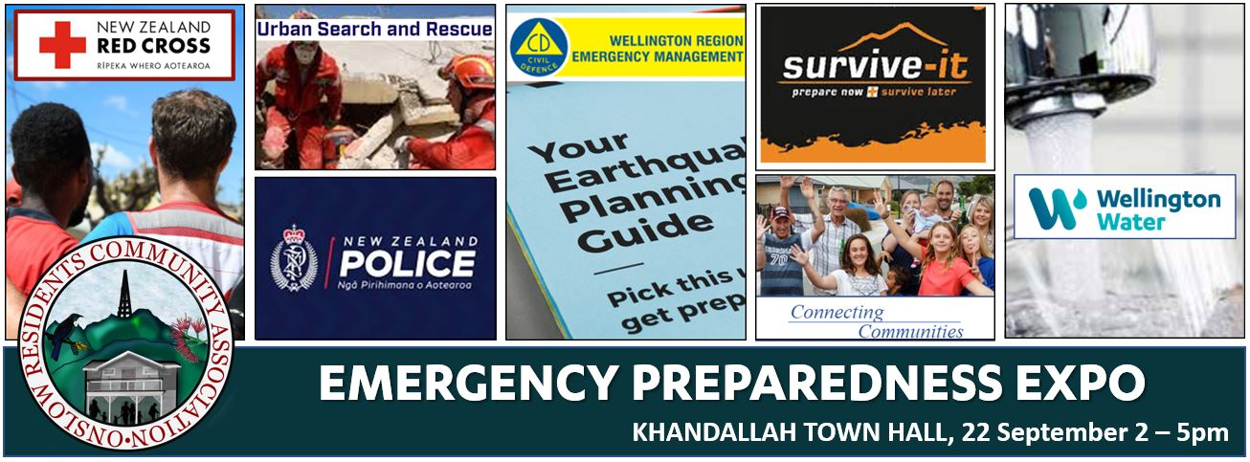
This free event is an afternoon when experts share their tips and ideas about how to be prepared and what to do in an emergency. There is an array of speakers on the programme including the WREMO (Emergency Management Office), Wellington Water, Red Cross, Urban Search and Rescue, Emergency Radio, NZ Police, how to compost a toilet and SURV-IT. Plus displays and afternoon tea. The full programme is available at https://onslowcommunity.org.nz/emergency-preparedness-expo/

Living Sustainably Expo – Tuesday 29 October 7-9pm
ORCA is holding an evening of environmental sustainability. Come and listen to Rachel Benefield (interviewed by Jesse Mulligan on Radio NZ) who will speak about how her family of five changed the way they live to become more environmentally sustainable.
Then hear from different groups about ways to be environmentally sustainable including:
- Establishing a community garden and composting – Kate from the Khandallah Community Garden
- Reducing reliance on petrol cars – barriers/solutions including an electric car display - Sigurd Magnusson from the NZ Electric Car Guide.
- Minimising Food Waste – Love Food Hate Waste New Zealand (Storing food, ways to use leftovers, recipes)
- All about Solar Energy- Tony Pearson, Future Energy Ltd
- Predator Free Khandallah/Broadmeadows – Gillian Bruce from Khandallah Predator Free
- How to make Beeswax Food Wraps – Scientist Wendy Popplewell will demonstrate

Local Body Elections Coming Up – 12 October 2019
You will have seen the billboards lining the streets which heralds local government election time. Local elections decide who is on our local council, regional council, district health board, and other important organisations in our area. These are the people who are elected to make decisions that affect our daily life and the future of Wellington. For electoral purposes, Wellington city is divided into 5 wards that elect a total of 14 Councillors. There are three Councillor’ positions for the Wharangi/Onslow-Western Ward. We also elect the Councillors for the Regional Council. The next election will be held on Saturday 12 October 2019 by postal vote using the Single Transferable Voting electoral system (STV). A candidates meeting was held at the Khandallah Town Hall earlier in the month. We note that two of our members are running again: Diane Calvert and Ray Chung. You can see who else is running here at https://wellington.govt.nz/your-council/elections/local-elections-2019/nominated-candidates/wharangi-onslow-western-ward. ORCA encourages our community to vote – be a responsible citizen to keep our democracy working.
Next Candidates Meeting, 20 September 7pm at the Ngaio Town Hall

ORCA Visit to Wellington Water’s Emergency Station
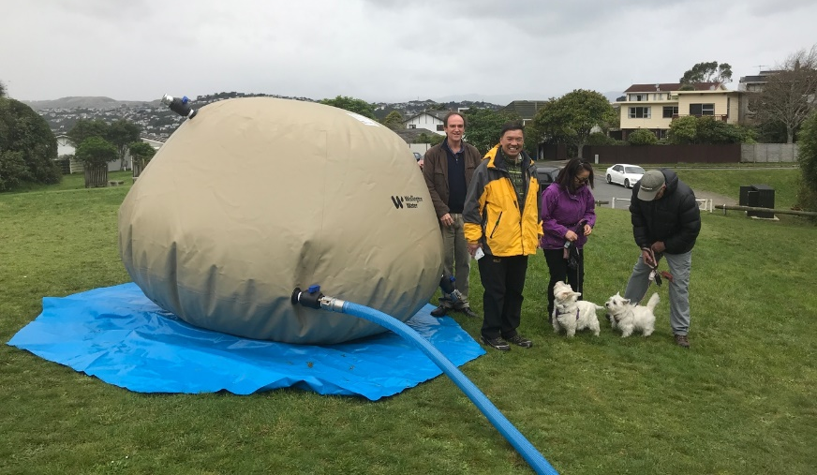
The ORCA team visited Wellington’s Water’s Emergency Water Treatment Plant at Truscott Park recently. We learned that Wellington’s water supply network is vulnerable. After a significant earthquake the Northern suburbs will be without water for 40 plus days. Wellington Water is working hard to make sure communities are prepared. Community water stations are strategically located at 21 sites across urban Wellington. In our areas we have water stations in Clarke Street, Khandallah, and Truscott Avenue in Johnsonville and Huntleigh Park in Crofton Downs. It was stressed that we need to have enough water stored at home for at least seven days. After that the emergency water stations will kick in and provide water that will be stored in huge bladders. The community can come and get 20 litres a day. Read more about the emergency water stations here: https://www.wellingtonwater.co.nz/your- water/emergency-water/

Keeping Watch over Our Street Lighting
ORCA Co-Vice President, Ray Chung and his wife Lorraine when walking their dogs, Lillee and Hollee around their suburb, Broadmeadows, check out the state of the lighting. This is particularly since the change from Sodium-vapour lights to LED lights. They found that in winter it can be very dark and they called WCC street-lighting engineers to assess the lighting especially near 11 Rajkot Terrace, 77 Kanpur Road and top of Kanpur Road.
Ray, who leads ORCA’s planning and infrastructure committee, pointed out that bus stops and intersections need to be brighter and he got the Council to upgrade the 700 watt LED's in these areas. New lamp posts have been erected in Kanpur Road but they are still waiting for the Rajkot Terrace lamp post to be installed. Rays says the street lighting standard requires no "black" areas between street lights. In some locations, the light is blocked by trees and vegetation and he reports these to the WCC too.
We encourage all residents in Broadmeadows, Khandallah and Kaiwharawhara to check out the street lighting on their streets and contact the Council with any issues at https://wellington.govt.nz/services/parking-and-roads/how-we-light-wellington

Khandallah Community Garden Update
The Khandallah Community Garden AGM will be held on Tuesday, 15 October at 7.30pm at Khandallah Town Hall. All very welcome.
Working bees are on the last Sunday of the each month. The next being on Sunday 29 September from 2-4pm.
For more information email Jenny Rafferty at edjen@xtra.co.nz

Planning for Growth of Wellington City

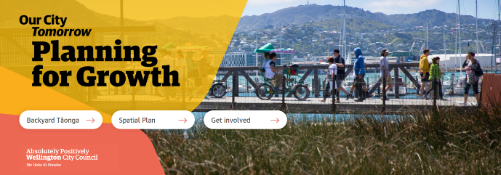
ORCA is monitoring Wellington City’s Planning for Growth strategy. The District Plan will soon be up for review and the Council is making decisions that will impact the way Wellington looks and how we live for many years.

The Council came up with four scenarios to cope with growth. ORCA was one of 1374 people and groups who made submissions on these four options. You can read ORCA’s submission here. We understand that of the options, WCC is only considering the ones that involve inner city and suburbs. ORCA is concerned that given the risk of earthquakes, and the fact that the whole inner city would be evacuated to somewhere north of Wellington in the big one, that other options are not considered. Read more about the Council’s planning for growth.

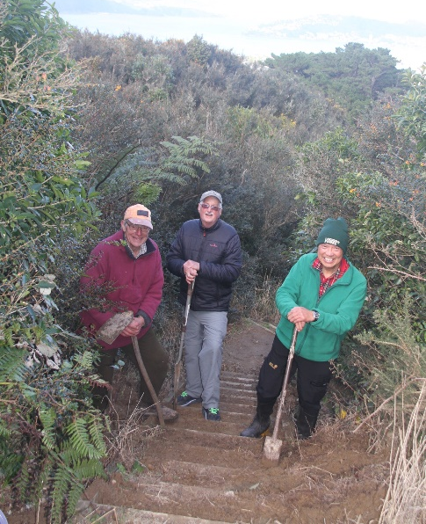
Keeping Kaukau Tracks Clear
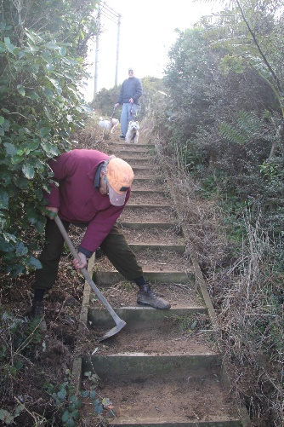
ORCA members Richard Campbell, Ray Chung and Gary Morrison recently held a mini working bee on the main track on Mount Kaukau clearing the drains between the first lookout point before the track joins the Northern walkway. This enables water to drain off to the lower side of the track. They also made the steps safer, digging out the build-up of dirt and returning the tread to a flat surface. While working, and in testament to the popularity of this walk along the Northern Walkway, over 20 people passed by and expressed their gratitude for making their walkway safer.
Mt. Kaukau has been a very popular place for hikers, families and runners for many years now. While the more popular tracks are well maintained, some of the paths and tracks used especially off the Broadmeadows area, haven't been getting the maintenance to continue to make it safe and enjoyable. So thanks to Ray, Gary and Richard for sorting this out for us.
How to keep our streams contaminant free:
1. Pick up litter on the streets. Cans, plastic bags and cigarette butts wash into the stream and out to sea.
2. Pick up dog’s droppings and dispose. If they wash into the storm water or stream, they increase pathogens in our waterways.
3. Clean your car on the lawn without detergent, or take it to a car wash. Detergent causes algae to grow.
4. Grass clippings and leaves block drains and in water use the oxygen needed for insect life.
5. Dispose of paint and brushes properly. Leaving left-overs of paint and solvents to dry out rather than pouring them down the drain. Paint and oil suffocate fish and insects and contain heavy metals that are toxic.
6. Take household chemicals, waste oil etc. to the specific sections at official landfills.
8. Shovel up cement and concrete when you build. Never wash concrete waste into the stormwater system. Cement and concrete waste kills fish and insects and the fine particles smother stream life.
9. Don’t wash soil, sand or rubbish into the stormwater system. Dirt and sediment clogs fishes’ gills, making it harder for them to breathe. It reduces water clarity too making it harder for fish to find food and starves water plants of light and encourages weed growth.

Bell's Track Update
The Bell’s Track Working Group maintains the Bell's track with the aim to regenerate the forest type that was originally there and also predation and weed control. Working bees are the first Sunday of every month meeting at end of Awarua Street at 10.30 am. Or you can just adopt a spot.

The Group also maintains the area around Awarua Street Station and the entrance to Cummings Park from Awarua Street. Working bees are every Tuesday meeting at Awarua Street Station at 11 am. Co-ordinator Des says the plan here is to have more groups involved in maintaining around the stations on the Johnsonville line and turning this into a native plant corridor. They also maintain the reserve between 72 and 94 Awarua Street. For more information contact Des Smith at desjohn@xtra.co.nz.

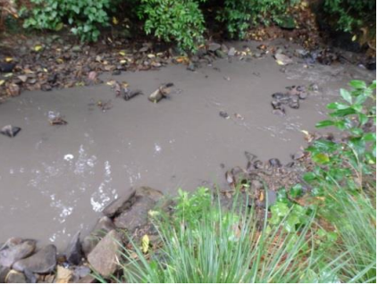
Keeping Waitohi Stream Clean
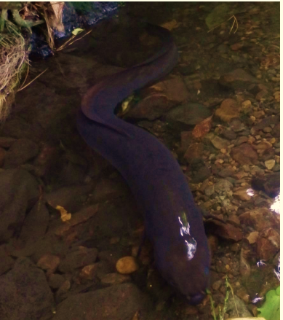
ORCA member Lyne Cadenhead advises us that there is ongoing pollution in Khandallah/Tyers Stream from pollutants being put into the stormwater system by Khandallah and Broadmeadows residents. She urges us to put only rainwater in the stormwater system. Putting anything else down the drain is illegal.
This pollution impacts children playing and native fish living in the stream. This includes the 1.2m longfin eel and the 230mm banded kokopu which live in Tyers Stream.
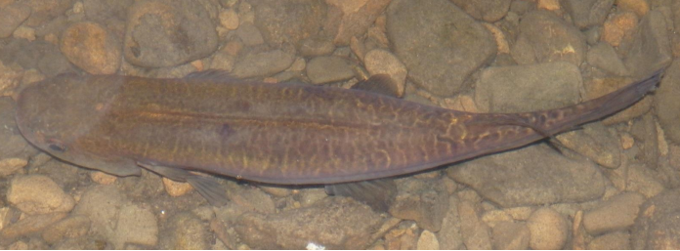
If you see somebody dumping waste into the stormwater drain or see a polluted stream, call the Greater Wellington Regional Council Pollution Hotline 0800 496 734

Responsible Dog Owner’s Course

Sunday 3 November 2019, 2 - 4 pm, Khandallah Town Hall.


To encourage and recognise good dog owners, the Council offers a reduced dog registration fee for people who achieve Responsible Dog Owner (RDO) status. The Council will provide a reduced dog registration fee if dog owners qualify as a RDO.
You can become an RDO if you have attended and passed an approved Responsible Dog Owner Education and Obedience course, your annual dog registration fees have been paid on time and your dog has free access to a fully-enclosed containment area on your property (this doesn't have to be a fully-fenced garden or yard). For more information contact Martin Jenkins on 027 604 7329.

Khandallah Village Street Fair
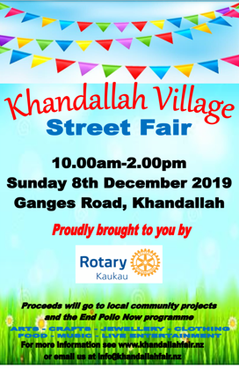
Come and see the ORCA stall at Rotary’s Christmas Fair. Thanks Kaukau Rotary for once again holding this event.


If you are interested in becoming a member of Kaukau Rotary, contact the President, Prue Harrison at Prue.Harrison@ajpark.com.

Join ORCA Today
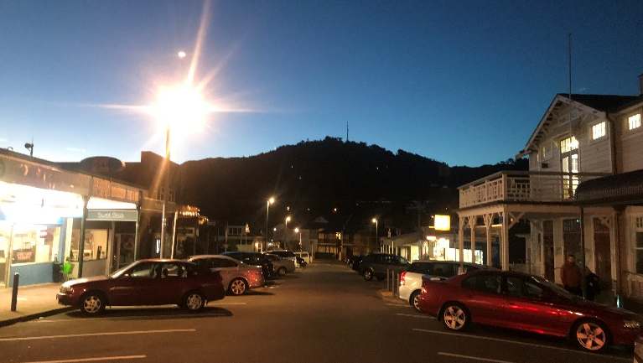
If you haven’t already – why don’t you join ORCA? Subscription is $10 annually. Membership is open to all residents, businesses and community groups in Khandallah, Broadmeadows and Kaiwharawhara. Email us for a membership application at onslowcommunityassn@gmail.com or download it from our website at https://onslowcommunity.org.nz/ or call Ron Gall, Membership Secretary on 0274 466 838 or 04 479 3653.

Meet our 2019 Committee
ORCA meets the 2nd Wednesday of each month at 7:30pm Khandallah Town Hall.
ORCA committee members and officers are: Nicola McFaull (President), Ray Chung (Co-Vice-President), Tania Thomas (Co-Vice-President), Lance Pratley (Secretary), Lachman Prasad (Treasurer), Ron Gall (Membership Secretary), Richard Campbell, Martin Jenkins, Wilma Sherwin, Shirley Morrison, Ron Zoest and Lance Collingbourne.
We meet at 7:30pm on the second Wednesday of each month in the downstairs lounge at the Khandallah Town Hall. All members are welcome to attend our committee meetings.

Sub-Committees
Committee members have organised themselves in areas of interest. If any residents or members have an issue that falls under these portfolios – please don’t hesitate to contact the convenor.
Portfolio | Contact | Phone
Housing, Infrastructure & Planning | Lachman Prasad | 027 243 2128
Environment and Parks | Shirley Morrison | 027 655 2664
Transport and Road Safety | Wilma Sherwin | 021 299 7433
Financial Management | Lachman Prasad | 027 340 1375
Communications | Nicola McFaull and Tania Thompson | 0274 511 366
Secretary | Lance Pratley | 04 479 6949

